TASK 7 – EVALUATE PROCESS CONTROL SYSTEM CALLS

1. Aim
To study process control system calls and demonstrate process creation, program execution and process termination using fork(), execvp() and waitpid().

2. Introduction
Process control is an important function of an operating system.
A process is a program that is currently executing. The operating system manages processes and allocates CPU resources to them.
Linux provides system calls such as fork(), exec(), waitpid() and exit() to manage process execution.

3. Important Process Control System Calls

A. fork()
The fork() system call creates a new child process.
The child process is initially a copy of the parent process.

B. exec()
The exec() family of functions replaces the current process image with a new program.
In this experiment, execvp() is used to execute an external command.

C. waitpid()
The waitpid() system call allows the parent process to wait for a particular child process.
It also collects the child's termination status.

D. exit()
The exit() function terminates a process and returns an exit status.
The _exit() system call terminates the process without flushing inherited standard I/O buffers.

4. C Program for Process Control
File Name: process.c
#define _POSIX_C_SOURCE 200809L
#include <stdio.h>
#include <stdlib.h>
#include <unistd.h>
#include <sys/types.h>
#include <sys/wait.h>

int main(void)
{
pid_t pid;
int status;

printf("shell: running job 1\n");
fflush(stdout);

pid = fork();

if (pid < 0) {
perror("fork");
return 1;
}

if (pid == 0) {

char *args[] = {"expr", "6", "*", "7", NULL};

execvp("expr", args);

perror("execvp");
_exit(127);
}

if (waitpid(pid, &status, 0) < 0) {
perror("waitpid");
return 1;
}

if (WIFEXITED(status))
printf("job 1 exit status %d\n", WEXITSTATUS(status));

printf("shell: running job 2\n");
fflush(stdout);

pid = fork();

if (pid < 0) {
perror("fork");
return 1;
}

if (pid == 0) {
_exit(3);
}

if (waitpid(pid, &status, 0) < 0) {
perror("waitpid");
return 1;
}

if (WIFEXITED(status))
printf("job 2 exit status %d\n", WEXITSTATUS(status));

return 0;
}

5. Compilation and Execution
Compilation command:
gcc -Wall -Wextra -std=c11 process.c -o process
Execution command:
./process

Actual Output
shell: running job 1
42
job 1 exit status 0
shell: running job 2
job 2 exit status 3

6. Explanation of the Output
The program performs two jobs.
Job 1:
- The parent process creates a child using fork().
- The child executes the expr command using execvp().
- The expression 6 × 7 is calculated.
- The result 42 is displayed.
- The parent waits using waitpid().
- The child exits successfully with status 0.
Job 2:
- The parent creates another child process.
- The child terminates using _exit(3).
- The parent waits for the child.
- The exit status 3 is collected.

7. System Call Tracing Using strace
The following command was used:
strace -f -e trace=clone,fork,vfork,execve,wait4,exit,exit_group ./process
The -f option follows child processes.
Important observations from the actual output:
clone(...) = 11393

execve("/usr/bin/expr", ["expr", "6", "*", "7"], ...) = 0

wait4(11393, ...) = 11393

exit_group(0) = ?

exit_group(3) = ?
Linux may internally implement fork() using clone().
The output also shows that execve() successfully executed the expr program and wait4() collected the child process status.
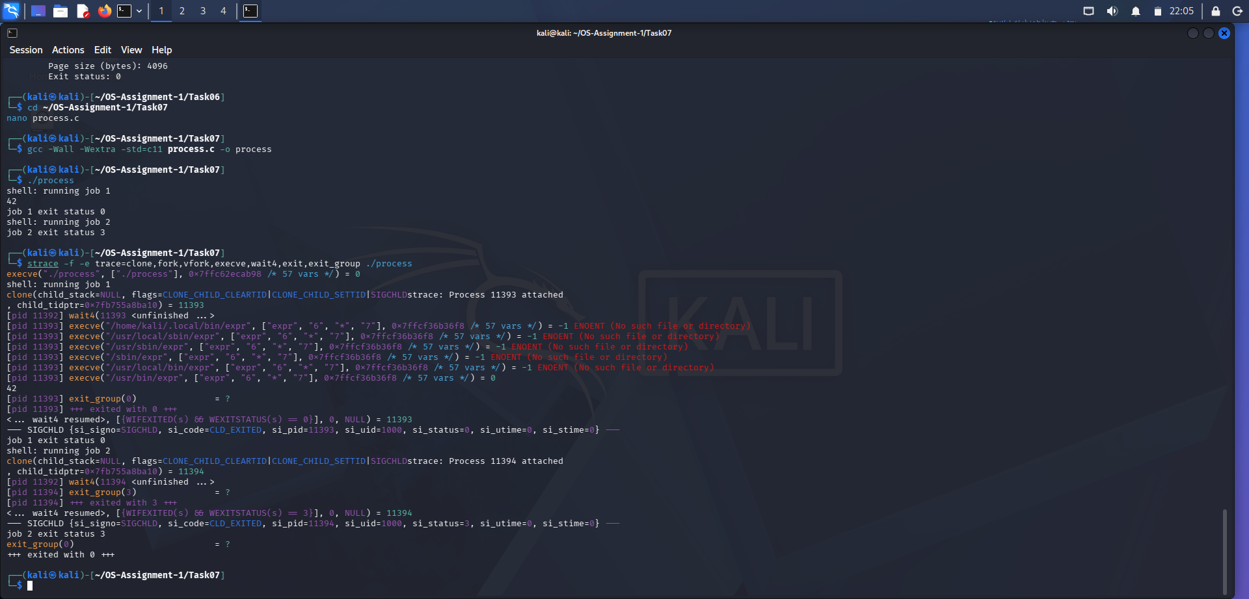

8. Importance of fflush(stdout)
The fflush(stdout) function is used before fork() to clear the standard output buffer.
After fork(), the parent and child processes have separate copies of their memory.
If buffered output is not flushed before process creation, both processes may later flush the same copied data and produce duplicate output.
Therefore, fflush(stdout) is useful before fork() when buffered output must not be duplicated.

9. Zombie and Orphan Processes

Zombie Process
A zombie process is a child process that has terminated but whose exit status has not yet been collected by the parent.
The waitpid() system call helps remove zombie processes by collecting the child's termination status.

Orphan Process
An orphan process is a child process whose parent terminates before it.
The operating system reassigns the orphan to an appropriate system process.

10. Alternative Concept – posix_spawn()
posix_spawn() is an alternative interface for creating a process and executing another program.
It can combine process creation and execution into one operation.
Comparison:
Feature | fork() + exec() | posix_spawn()
Process creation | Separate fork() call | Combined interface
Program execution | Separate exec() call | Included
Flexibility | High | Depends on spawn attributes
Usage | Traditional process management | Convenient program launching
Threads are another alternative for concurrent execution. Threads share the same process memory, whereas separate processes have independent virtual address spaces.

11. Complexity Analysis
For the given program, two child processes are created.
Process Creation: Each fork() creates one child process.
Execution: Job 1 executes an external expr program.
Waiting: The parent waits for each child before continuing.
The cost of process creation depends on memory management, scheduling and operating system implementation.
For a larger workload involving 1,000 processes, the total execution time and memory usage must be measured experimentally.

12. Conclusion
The experiment successfully demonstrated process creation, program execution and termination using fork(), execvp() and waitpid().
The first child process calculated 6 × 7 and returned exit status 0. The second child process returned exit status 3.
The strace utility helped observe clone(), execve(), wait4() and exit_group() system calls.
Therefore, process control system calls are important for managing multiple processes in a Linux operating system.

